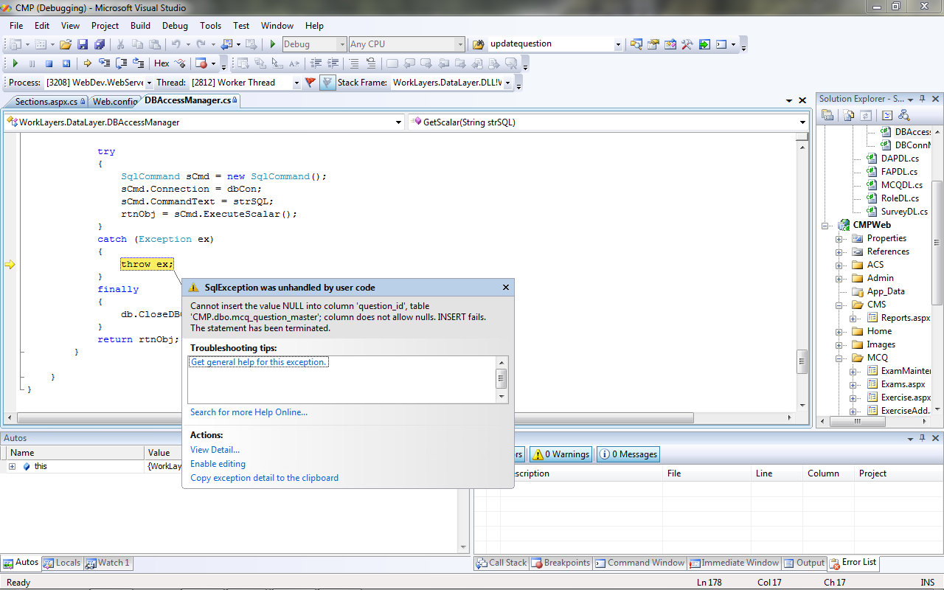

Exam -> Manage Section -> Manage Question
Fill in question details and click Add. The above error displayed.

